Name: V Vishwa Teja ID number: 2520090033
Week 3
Task 1: To Create Main Loop, Display Prompt, Read User Input, Handle Exit Conditions, Design Control Flow Diagram, Test Interactive Loop
- Create a file by using
Then press enter and the code terminal will open then write a code
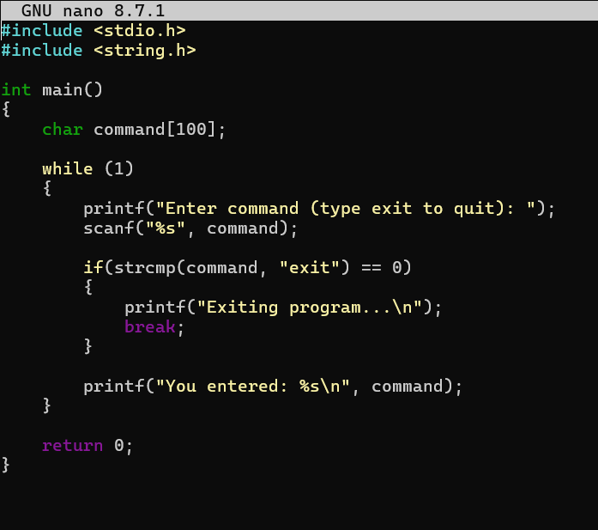
After writing the code save the your program by ctrl O and for coming back to command press ctrl X then compile it by the command
After compiling to get the output enter command
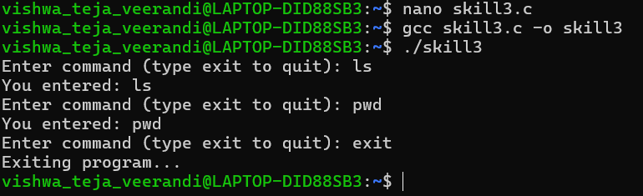

Task 2: Using the following system calls, copy the content from File1.txt to File2.txt.
- Open()
- Read()
- Write()
- Close()
Flag | Purpose
O_RDONLY | Open for read only
O_WRONLY | Open for write only
O_RDWR | Open for both read and write
O_CREAT | Create file if it does not exist
O_TRUNC | Truncate (empty) an existing file
O_APPEND | Append data to the end of the file
O_EXCL | Fail if file already exists (used with O_CREAT)

1) Create a file
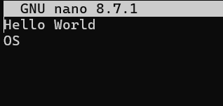

2) Create another file
